| **Name : Yash Sarang** | **Class/Roll No. : 47** | **Grade :** |
| --- | --- | --- |

**Title of Experiment :** Creating a Wireframe on selected problem statements.

**Objective of Experiment :** The objective of this experiment is to design a wireframe for a user-friendly and efficient banking process on a bank's website. The wireframe will serve as a visual representation of the interface, allowing us to identify potential usability issues and streamline the banking experience.

**Outcome of Experiment :**  Created a Wireframe for the Pharmacy Website

**Problem Statement :** Create A Wireframe for Bank of India Website

**Description / Theory :**

**Prototyping:**

Prototyping is a fundamental concept in the field of product and software development. It involves creating a preliminary, simplified version of a product or system to visualize and test its functionality, design, and features before committing to full-scale development. Prototypes are essential for gathering user feedback, clarifying requirements, and identifying potential issues early in the development process.

**High Fidelity Prototype:**

High-fidelity prototyping is an advanced design technique that involves creating highly detailed and realistic prototypes of products or systems. These prototypes closely resemble the final product in terms of design and functionality, allowing for in-depth user testing, requirement validation, and improved communication with stakeholders. High-fidelity prototypes help reduce development risks and ensure the final product meets user expectations.

In summary, high-fidelity prototypes are comprehensive and sophisticated representations of a product or system, offering a realistic user experience, in-depth testing capabilities, and insights into design feasibility. They are a crucial step in the product development process, helping ensure that the final product aligns with user expectations and project requirements.

**Wireframe / High Fidelity Prototype:**

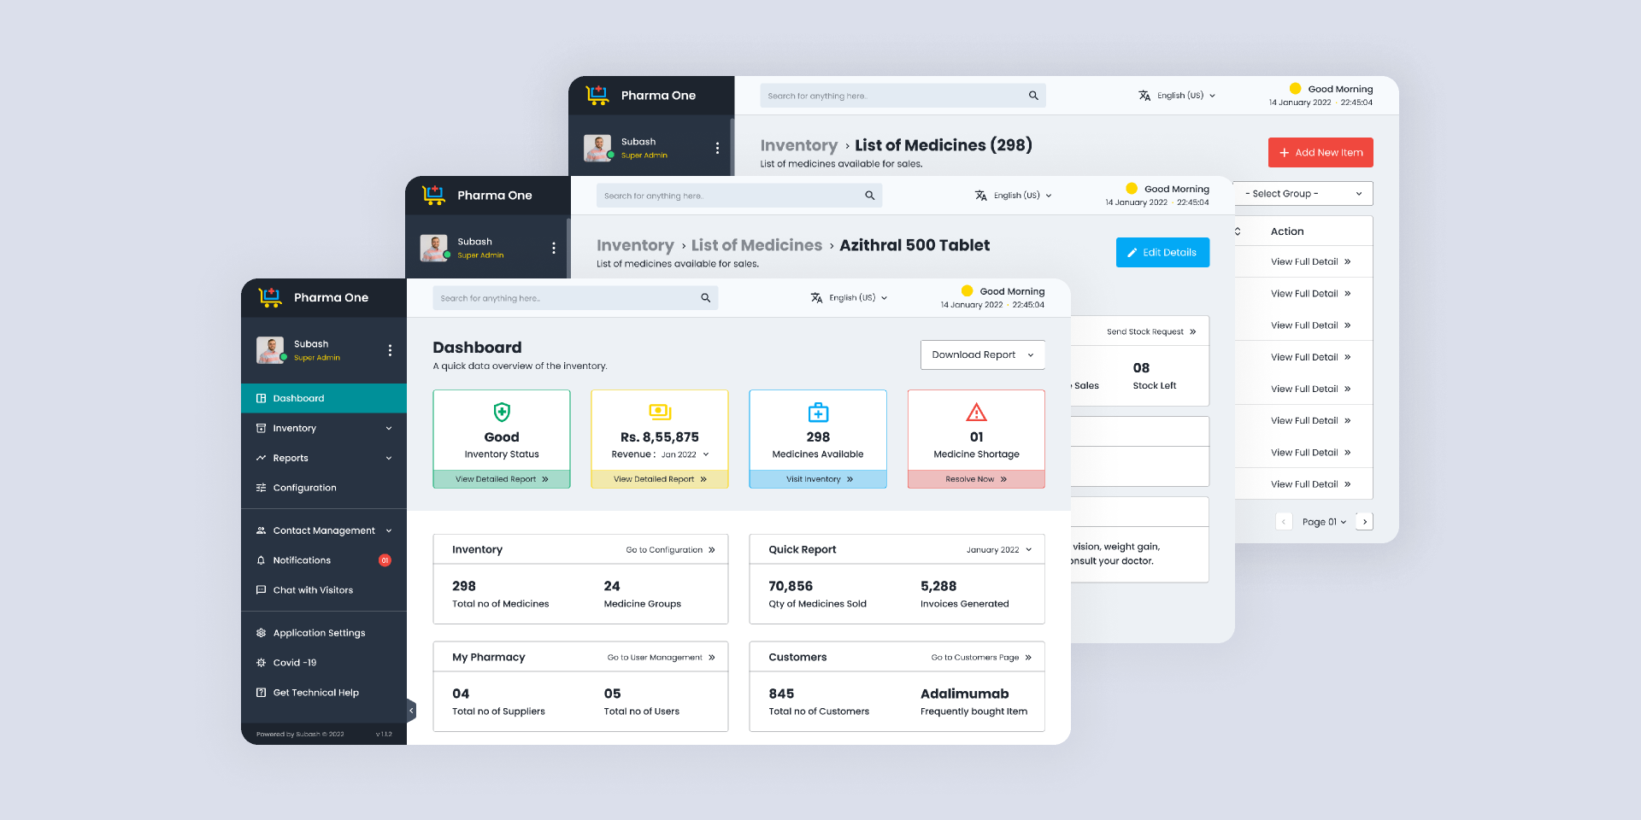

**Results and Discussions :**

The high-fidelity prototype website using Figma has been successfully developed, closely resembling the final product in design and functionality. The prototype enabled realistic user testing and feedback, validated project requirements, and supported collaboration among team members. Despite the time and resource investment, the iterative design process resulted in a user-friendly, modern website that aligns with stakeholder expectations.

**\*\*\*\*\***